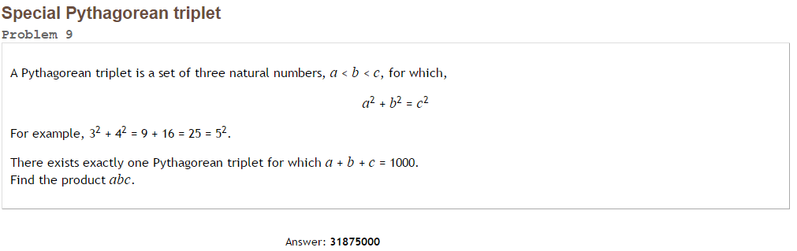Project Euler #9 – Pen & Paper Solution

We know that any “Pythagorean Triple” can be [uniquely parametrized](https://en.wikipedia.org/wiki/Pythagorean_triple#Interpretation_of_parameters_in_Euclid.27s_formula).

Let.

From 

.

The only solution here is: .

It follows: .

 = [31875000](http://www.wolframalpha.com/input/?i=15+8+17+25%5E3)